These cURL commands should allow you to test the various functionalities of your REST API, ensuring that it behaves as expected in each scenario.

There are seven cURL commands below:

**1. Get All Courses**

Retrieve a list of all courses.

curl -X GET -s http://localhost:8080/courses | tr ',' '\n'

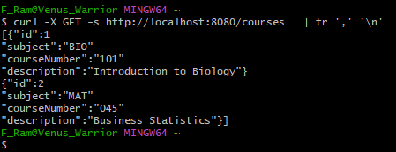

**2. Get Course by ID**

curl -X GET -s http://localhost:8080/courses/2 | tr ',' '\n'

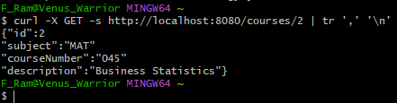

**3. Search for a Course by Description**

curl -X GET <http://localhost:8080/courses/search?description=Bio>

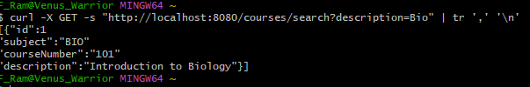

**4. Add a New Course**

curl -X POST -H "Content-Type: application/json" -H "Accept: application/json" -d '{"id":3,"subject":"PHY","courseNumber":"201","description":"Physics Fundamentals"}' <http://localhost:8080/courses>

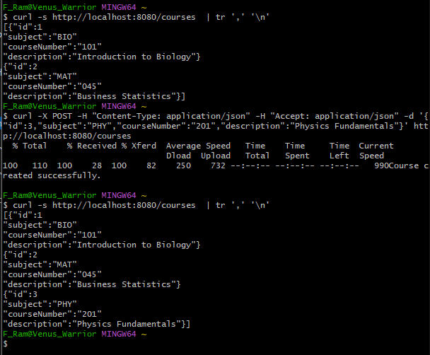

**5. Prevent Adding a Duplicate Course**

curl -X POST -H "Content-Type: application/json" -H "Accept: application/json" -d '{"id":4,"subject":"PHY","courseNumber":"201","description":"Advanced Physics"}' http://localhost:8080/courses

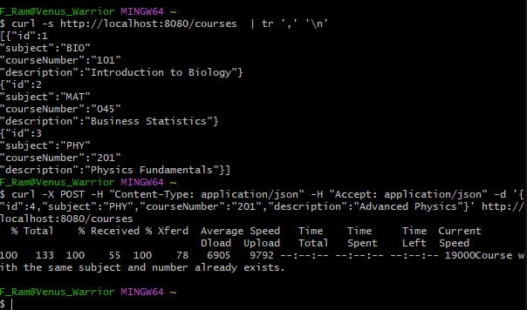

**6. Delete a Course**

Delete a course by its ID.

curl -X DELETE <http://localhost:8080/courses/1>

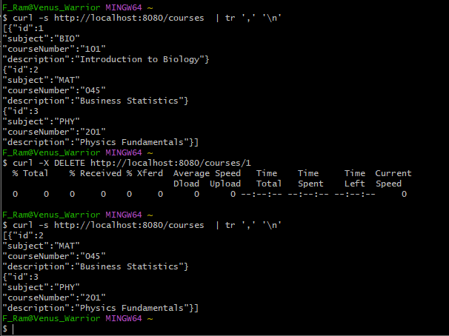

**7. Attempt to Add a Course with Invalid Course Number**

Try to add a course with an invalid course number (not a three-digit number).

curl -X POST -H "Content-Type: application/json" -H "Accept: application/json" -d '{"id":5,"subject":"CHE","courseNumber":"2","description":"Chemistry Basics"}' http://localhost:8080/courses

